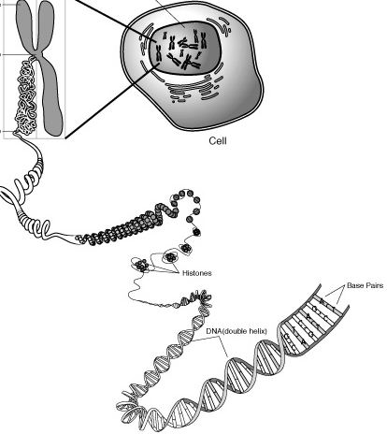
Name:
Chromosomes, Genes & DNA
Identify on the diagram above and write a description for each of the following:
Chromosome:
Centromere
Chromatid
Nucleus
Gene
Histone
Chromatin
Nucleotide

